MODULE 3
Lecture # 1

1) Synopsis: Oscillators
2) Target: At the completion of this lecture you should be able to answer questions like
a) What is an oscillator?
3) Introduction
An oscillator is a device which produces oscillations when dc supply is given
to it. Every oscillator has at least one active device be it a transistor or even valve. In a way it
is a something which converts a constant form of energy (dc supply) to a fluctuating one (ac
oscillations). All oscillators work on positive feedback.

4) Revision / Prerequisites
Basic concepts of oscillation
5.1) Concept #1
An oscillator is a device which produces oscillations when dc supply is given
to it. Major requirement for an oscillator’s performance is that of frequency stability. The
frequency stability of an oscillator is a measure of its ability to maintain as nearly a
fixed frequency as possible over as long a time interval as possible. Often, the
stability is measured as a few hertz per megahertz per hour.

Circuit components, transistor parameters, supply voltages, stray capacitances etc. are
the circuit features on which the oscillation frequency depends. The deviations of
frequency arise because the values of these circuit features do not remain constant in
time.
5.2) Concept #2
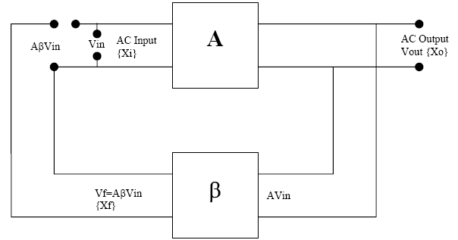

In the amplifier circuit. Suppose an input signal x_{i} is applied. This signal enters the
base amplifier and an amplified signal is obtained at the out side. This output x_{o} is sampled and fed back to the input by the feed back network. Now consider that input xi is removed so that at the input side only the sample signal x_{f} is present. This x_{f} enters the base amplifier and is amplified and fed back to the input. Now if the loop gain of the circuit Aβ= 1 the input signal x_{i} is generated continuously at the output.
This will occur only if certain conditions are satisfied, they are called Barkhausen
Criterion. According to it the loop gain of the oscillating circuit should be equal to unity and the phase difference should be zero, or an integral multiple of 2π.

In a practical oscillator the input impulse xi is not given. It is generated as a noise
signal within the active devices. In active devices random noise signals of different
frequencies and amplitudes are generated when power is supplied. At turn on, when power is first applied, random noise is generated within the active device and then amplified. This noise is fed back positively through frequency selective circuits to the input where it is amplified again and so on. Ultimately a state of equilibrium is reached at a particular frequency where the losses in the circuit are made good by consuming power from the power supply and the Barkhausen Criterion is satisfied. The frequency of oscillation is determined by the inductors and capacitors (L.C.) or a crystal. The amount of positive feedback to sustain oscillation is also determined by external components.

The main application of positive feedback is in oscillators. An oscillator
generates AC output signal without any input AC signal. A part of the output is fed back to the input and this feedback signal is the only input to the internal amplifier. This signal is amplified again and again to produce oscillations. In positive feedback the feedback voltage is in same polarity with the input signal. And this positive signal is amplified to produce oscillations. Thus positive feedback is used in an oscillator to increase the gain. The case of negative feedback the feedback voltage is in opposite polarity with the input signal. This is amplified to produce growing oscillation. Thus the gain will decrease.

5.3) Concept #3

THE BARKHAUSEN CRITERION
The frequency at which a sinusoidal oscillator will operate is the frequency for which
the total shift introduced, as a signal proceeds groom the input terminals, through the
Amplifier and feedback network, and back again to the input, is precisely zero (or multiple of 2pi).The frequency of a sinusoidal oscillator is determined by the condition that the loop-gain phase shift is zero.
It might be noted parenthetically that it is not inconceivable that the above condition
Might be satisfied for more than a single frequency in such a contingency there is a possibility of simultaneous oscillations at several frequencies or an oscillation at a single one of the allowed frequency.
Another condition which must clearly be met is that the magnitude of xi and xf ` must
be identical. Oscillations will not be sustained if, the oscillator frequency, the magnitude of the product of the transfer gain of the amplifier and the magnitude of the feedback factor of the feedback network are less than unity.
The condition of unity loop gain – Aβ = 1 is called Barkhausen criterion. This
condition implies both | Aβ | = 1 and that the phase of –Aβ is 0. The above principles are
consistent with feedback formula A_{f}.= A/ (1+Aβ). For if –Aβ=1, Then A_{f} →∞, which may be interpreted to mean that there exists an output voltage even in the absence of an externally applied signal voltage. In every practical oscillator the loop gain is slightly larger than unity, and the amplitude of the oscillations is limited by the onset of non-linearity.

Applications of Oscillators:
1. It is used in communication engineering as carrier wave generators.
2. It is used in digital electronics for clock pulses.
3. It is used for generating oscillating signals.
4. It has many applications in electronics
6.0) Summary
In this lecture we studied the principle of operation of oscillators and the condition essential for oscillation.

7.0) Exercise questions
1. Explain how feedback helps in producing oscillations in a circuit.
2. How an amplifier can be converted into an oscillator? Write the oscillation criteria.

Lecture # 2

1) Synopsis: Concept of feedback
Transistorized phase shift oscillator
2) Target: At the completion of this lecture you should be able to answer questions like
a) Principle of operation of a phase shift oscillator. b) Condition for oscillation
3) Introduction
An oscillator is a device which produces oscillations when dc supply is given
to it. All oscillators work on positive feedback.

4) Revision / Prerequisites
Oscillator
5.1) Concept #1
Concept of feedback
5.2) Concept #2
Transistorized phase shift oscillator
The circuit arrangement of a phase shift oscillator using N-P-N transistor in CE
configuration is shown in the figure below.
The voltage divider R1-R2 provides DC emitter base bias, RE and CE combination
provides temperature stability and prevent ac signal degeneration and the collector resistor RC
controls the collector voltage. The oscillator output voltage is capacitively coupled to the load
by C_{c}
Here the output of the feedback network is loaded appreciably by the relatively small
input resistance ( hie) of the transistor. Hence, voltage shunt feedback is used for a transistor
phase shift oscillator, as shown in the above figure. In this circuit, the feedback signal is
coupled through the feedback resistor R' in series with the amplifier stage input resistance
hie.The value of R’ should be such that when added with amplifier stage input resistance hie,it
is equal to R.
i.e., R' +hie=R.
5.3) Concept #3
OPERATION
The circuit is set into oscillations by any random or variation caused in the
base current that may be either due to noise inherent in the transistor or minor variation in voltage of dc supply. This variation in base current is amplified in the collector circuit. The output of the amplifier is supplied to an R-C feedback network. The R-C network produces a phase shift of 1800 between output and input voltages. Since CE amplifier produces a phase difference of the input signal, total phase shift becomes 3600 or 00 which is essential for the regeneration or for sustained oscillations. The output of this network is thus in the same phase as originally assumed input to the amplifier and is applied to the base terminal of the transistor. Thus sustained variation in the collector current between saturation and cut-off values are obtained. Here R-C phase shift network is the frequency determining network. The frequency of the oscillator output depends on the value of capacitors C and resistors R used in the phase shift network.
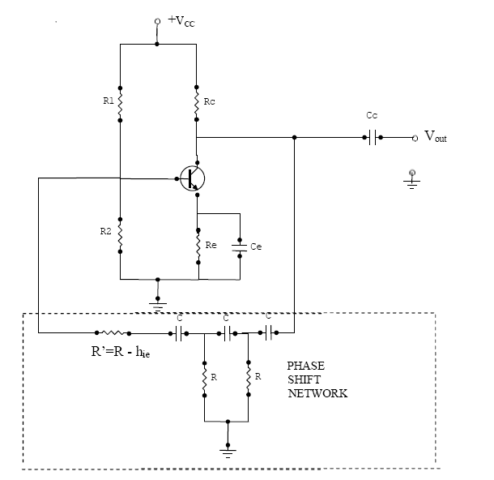

Frequency of oscillation
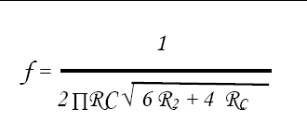

5.4) Concept #4
Advantages:
1. It is very cheap and a very simple circuit.
2. It provides good frequency stability.
3. It does not need negative feedback and stabilization.
4. The out put is sinusoidal and distortion free.
5. They have high frequency range.
6. They are particularly suited for low frequencies.
Disadvantages:
1. The output is small due to smaller feedback.
2. It is difficult for the circuit to start oscillations on its own.
3. The frequency stability is not very good.
4. It needs high voltage battery for feedback.
6.0) Summary
In this lecture, we studied the working of transistorized phase shift oscillator.
It provides good frequency stability. We learnt the frequency of oscillation.

7.0) Exercise questions
1. Describe the circuit diagram of a transistorized phase shift oscillator and its operation.
2. Explain how feedback helps in producing oscillations in a circuit.

Lecture # 3

1) Synopsis: Wein-bridge Oscillators
2) Target: At the completion of this lecture you should be able to answer questions like
a) Working of an Wein-bridge oscillator
3) Introduction
4) Revision / Prerequisites
Oscillator, concept of feedback, basic wein-bridge network
5.1) Concept #1

An oscillator circuit in which a balanced bridge is used as the feedback network is
the Wien bridge oscillator. It is one of the most popular type of oscillators used in audio and sub-audio frequency ranges (20-20kHz). This type of oscillator is simple in design, compact in size, and remarkably stable in its frequency output. Furthermore, its output is relatively free from distortion and its frequency can be varied easily. However, the maximum frequency output of a typical Wien bridge oscillator is only about 1MHz.

This is also in fact, a phase-shift oscillator. It employs two transistors, each producing
a phase shift of 180⁰, and thus producing a total phase-shift of 3600 or 00. It is essentially a two stage amplifier with an R-C bridge circuit. R-C bridge circuit (Wien bridge) is a lead-lag network. The phase-shift across the network lags with increasing frequency and leads with decreasing frequency. By adding Wien-bridge feedback network, the oscillator becomes sensitive to a signal of only one particular frequency. This particular frequency is that at which Wien bridge is balanced and for which the phase shift is 0⁰. If the Wien-bridge feedback network is not employed and output of transistor Q2 is feedback to transistor Q1 for providing regeneration required for producing oscillations, the transistor Q1 will amplify signals over a wide range of frequencies and thus direct coupling will result in poor frequency stability. Thus by employing Wien-bridge feedback network frequency stability is increased.
5.2) Concept #2
Wien bridge oscillator is one of the most popular type of oscillators used in audio and
sub audio frequency ranges (20 - 20 kHz). This type of oscillator is simple in design,
compact in size, + Vcc and remarkably stable in its frequency output. Furthermore, its output is relatively free from distortion and its frequency OUTPUT can be varied easily. However, the maximum frequency output of a typical Wien bridge oscillator is only about 1 MHz. It employs two transistors, each producing a phase shift of 180, and thus producing a total phase-shift of 360 or 0degree.
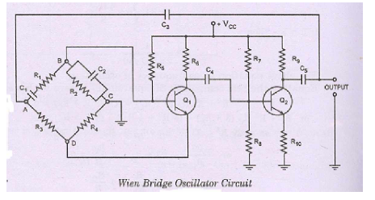
The circuit diagram of Wien bridge oscillator is shown in figure. It is essentially a
two- stage amplifier with an R-C bridge circuit. R-C bridge circuit {Wien bridge) is a lead lag network. The phase-shift across the network lags with increasing frequency and leads with decreasing frequency. By adding Wien-bridge feedback network, the oscillator becomes sensitive to a signal of only one particular frequency. This particular frequency is that at which Wien bridge is balanced and for which the phase shift is 0degree. If the Wien-bridge feedback network is not employed and output of transistor Q2 is fed back to transistor Q_{l} for providing regeneration required for producing oscillations, the transistor Q_{l} will amplify signals over a wide range of frequencies and thus direct coupling would result in poor frequency stability. Thus by employing Wien-bridge feedback network frequency stability is increased. In the bridge circuit R_{l} in series with C_{l}, R₃, R4 and R2 in parallel with C2 form the four arms.
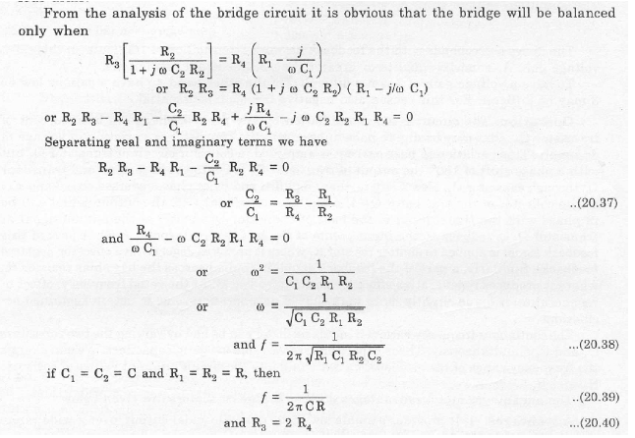
Thus we see that in a bridge circuit the output will be in phase with the input only
when the bridge is balanced i.e., at resonant frequency given by expression (20.39). At all
other frequencies the bridge is off-balance i.e. the voltage fed back and output voltage do not have the correct phase relationship for sustained oscillations. So this bridge circuit can be used as feedback network for an oscillator, provided that the phase shift through the amplifier is zero. This requisite condition is achieved by using a two stage amplifier, as illustrated in fig. In this arrangement the output of the second stage is supplied back to the feedback network and the voltage across the parallel combination C2 R2 is fed to the input of the first stage. Transistor Ql serves as an oscillator and amplifier whereas the transistor Q2 as an inverter to cause a phase shift of 180°. The circuit uses positive and negative feedbacks. The positive feedback is through Rl' C1, R2' C2 to transistor
Ql and negative feedback is through the voltage divider to the input of transistor Ql.

5.3) Concept #3
Advantages:
1. It provides a stable low distortion sinusoidal output over a wide frequency range.
2. The frequency range can be selected just by using resistant boxes.
3. The frequency can be varied by simply varying the capacitance.
4. The overall gain is high due to two transistors.
Disadvantages:
1. The circuit needs two transistors and a wide number of other components.
2. The maximum frequency output is limited.

6.0) Summary
In this lecture, we studied the working of wein-bridge oscillator.
We learnt the frequency of oscillation.

7.0) Exercise questions
1. Describe the working of wein-bridge oscillator
2. What are the advantages and disadvantages of wein-bridge oscillator?

Lecture # 4

1) Synopsis: Hartley Oscillators
2) Target: At the completion of this lecture you should be able to answer questions like
a) Working of Hartley oscillator
3) Introduction
The HARTLEY OSCILLATOR is an improvement over the Armstrong oscillator.
Although its frequency stability is not the best possible of all the oscillators, the Hartley
oscillator can generate a wide range of frequencies and is very easy to tune. The Hartley will operate class C with self-bias for ordinary operation. It will operate class A when the output waveform must be of a constant voltage level or of a linear wave shape.

4) Revision / Prerequisites
Oscillator, concept of feedback.
5.1) Concept #1
The two versions of this oscillator are the series-fed and the shunt-fed. The main difference between the Armstrong and the Hartley oscillators lies in the design of the feedback (tickler) coil. A separate coil is not used. Instead, in the Hartley oscillator, the coil in the tank circuit is a split inductor. Current flow through one section induces a voltage in the other section to develop a feedback signal.
5.2) Concept #2
The Hartley oscillator is widely used as a local oscillator in radio receivers.
Hartley oscillator is the same as colpitts oscillator except that phase shift network consists of two inductors L1 and L1 and a capacitor instead of two capacitors and one inductor. The output of the amplifier is applied across the inductor L1 and the voltage across inductor L2 is the feedback voltage. The coil L1 is inductively coupled to the coil L2, the combination functions as an autotransformer. However, because of direct connection, the junction of L1 and L2 cannot be directly grounded. Instead another capacitor is CL is used. The collector supply voltage Vcc is applied to the collector through a radio frequency choke, which permits an easy flow of direct current but at the same time, it offers very high impedance to the high frequency currents. The presence of the coupling capacitor Cc in the output circuit does not permit the dc currents to got to the tank circuit. The radio frequency energy developed across RFC is capacitively coupled to the tank circuit through the capacitor Cc. The output of the phase shift network is coupled from the junction of L2 and C to the amplifier input at base through coupling capacitor Cc, which blocks dc but provides path to ac. Transistor itself produces a phase shift of 180 degree and another phase shift of 180 degree is provided by the feedback. Thus a total phase shift of 360 degree is obtained which is an essential condition for developing oscillations. The output voltage derived from a secondary winding L’ coupled to the inductance L1.

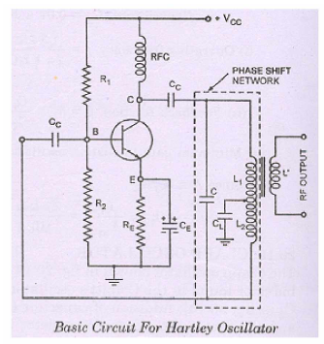

5.3) Concept #3
Working: - When the collector supply voltage Vcc is switched on, the capictor gets charged.
The capacitor discharges through the inductor, setting up oscillations of frequency: -
f=1/(2π*[C (L1+L2+2M)]1/2)
Considering the fact that there exists mutual inductance between the two coils because the
coils are wound on the same core, their net effective inductance is increased by mutual
inductance M. so in this case effective inductance -
L= L1+L2+2M.
Frequency of oscillation:
hie(Z1+Z2+Z3)+Z1Z2(1+ hfe )+Z2Z3=0
Here Z1=jwL1+jWM; Z2= jwL2+jwM and Z3=1/jWC= -j/W C

Substituting in the general equation
hie((jwL1+jwM) + (jwL2+jwM )+-j/w C)+ (jwL1+jwM ) (jwL2+jwM) (1+ hfe )+(jwL2+jwM )( -j/w C)=0
jwhie [L1+L2+2M-1/w2C] - w2 (L2+M)[(L1+M)(1+hfe)-1/ w2C]=0

Equating the imaginary part of above equation to zero
jWhie[L1+L2+2M-1/W²C]=0
L1+L2+2M-1/W²C=0
Or
W²C= 1/(L1+L2+2M)
or
f=W/2π=1/(2π*[C (L1+L2+2M)]1/2)

Advantages:
Frequency simply varied by capacity net value in the tank circuit.
Output amplitude remains constant (over the frequency range).
Feedback ratio of inductor 1 to inductor 2 remains constant.

Disadvantages:
Harmonic content rich.
Not suitable for a pure sine wave.

6.0) Summary
In this lecture, we studied the working of Hartley oscillator.
We learnt the frequency of oscillation.
7.0) Exercise questions
1. With the help of a neat circuit diagram, describe a Hartley oscillator. Give the condition for generating sustained oscillations in it.

Lecture # 5

1) Synopsis: Colpits Oscillators
2) Target: At the completion of this lecture you should be able to answer questions like
a) Working of Colpits oscillator
3) Introduction
Colpitts oscillators are somewhat similar to the shunt fed Hartley circuit except the
Colpitts oscillator, instead of having a tapped inductor, utilizes two series capacitors in its LC
circuit. With the Colpitts oscillator the connection between these two capacitors is used as the
center tap for the circuit.
4) Revision / Prerequisites
Oscillator, concept of feedback.
5.1) Concept #1
The basic Colpitts oscillator circuit looks like this and you will see some similarities
with the Hartley Oscillator.
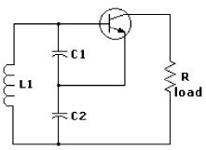
The figure below gives the circuit of a colpitts oscillator.

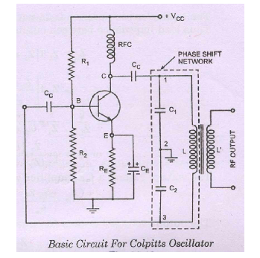
5.2) Concept #2
The Colpitt's oscillator circuit is a superb circuit and is widely used in commercial signal
generators up to 100 MHz. The basic circuit of a Colpitt's oscillator is shown in fig. It basically consists of a single stage inverting amplifier and an L-C phase shift network, as obvious from the circuit diagram shown. The two series capacitors C1 and C2 form the potential divider used for providing the feedback voltage-the voltage developed across capacitor C2 provides the regenerative feedback required for sustained oscillations. Parallel combination of R_{E} and CE along with resistors Rl andR2 provides the stabilized self bias. The collector supply voltage V cc is applied to the collector through a radiofrequency choke (RFC) which permits an easy flow of direct current but at the same time it offers + Vcc very high impedance to the high frequency currents. The presence of coupling capacitor Cc in the circuit, which blocks dc but provides path for ac.

Transistor itself produces a phase shift of 180 and another phase shift of 180 is
provided by the capacitive feedback. Thus a total phase shift of 360 is obtained which is an essential condition for developing oscillations. The output voltage is derived from a
secondary winding L' coupled to Basic Circuit For Colpitts Oscillator, the inductance L. The frequency is determined by Fig. the tank circuit and is varied by gang-tuning the two
capacitors C₁and C₂. It is to be noted that capacitors C₁ and C₂are ganged. As the tuning is varied, values of both capacitors vary simultaneously, the ratio of the two capacitances
remaining the same.

Circuit operation
When Vcc is applied the capacitorsC1 and C2 are charged. These capacitors are
discharged through the inductance L and thereby set up damped harmonic oscillations in the tank circuit. The oscillation across C1 is applied to base emitter junction and appears in amplified form in the collector circuit and supply losses to tank circuit. The amount of
feedback depends upon the values of C1 and C2.Higher the value of C1, smaller is the
feedback.

6.0) Summary
In this lecture, we studied the working of Colpits oscillator.
We learnt the frequency of oscillation.

7.0) Exercise questions
1. Explain with figures the principle of operation of a Colpitts oscillator. Derive its frequency of oscillation also

+

